Crennotech Vulnerability Scanner Design Document

Introduction
This document describes the design of the Crennotech Vulnerability Scanner, a web application security testing platform built for ISO 27001 compliance. The platform allows security engineers to trigger vulnerability scans against web targets through a REST API. Results are stored in SQL Server for audit and review.
The deliverable is a .NET 8 backend API that integrates OWASP ZAP for dynamic security testing. Hangfire manages background job execution. Entity Framework Core handles database access.
This design covers system architecture, data model, scanner integration, threat model, and deployment.

System Architecture
The platform has four layers: client, application, scanner, and data. Figure 1 shows the component relationships.
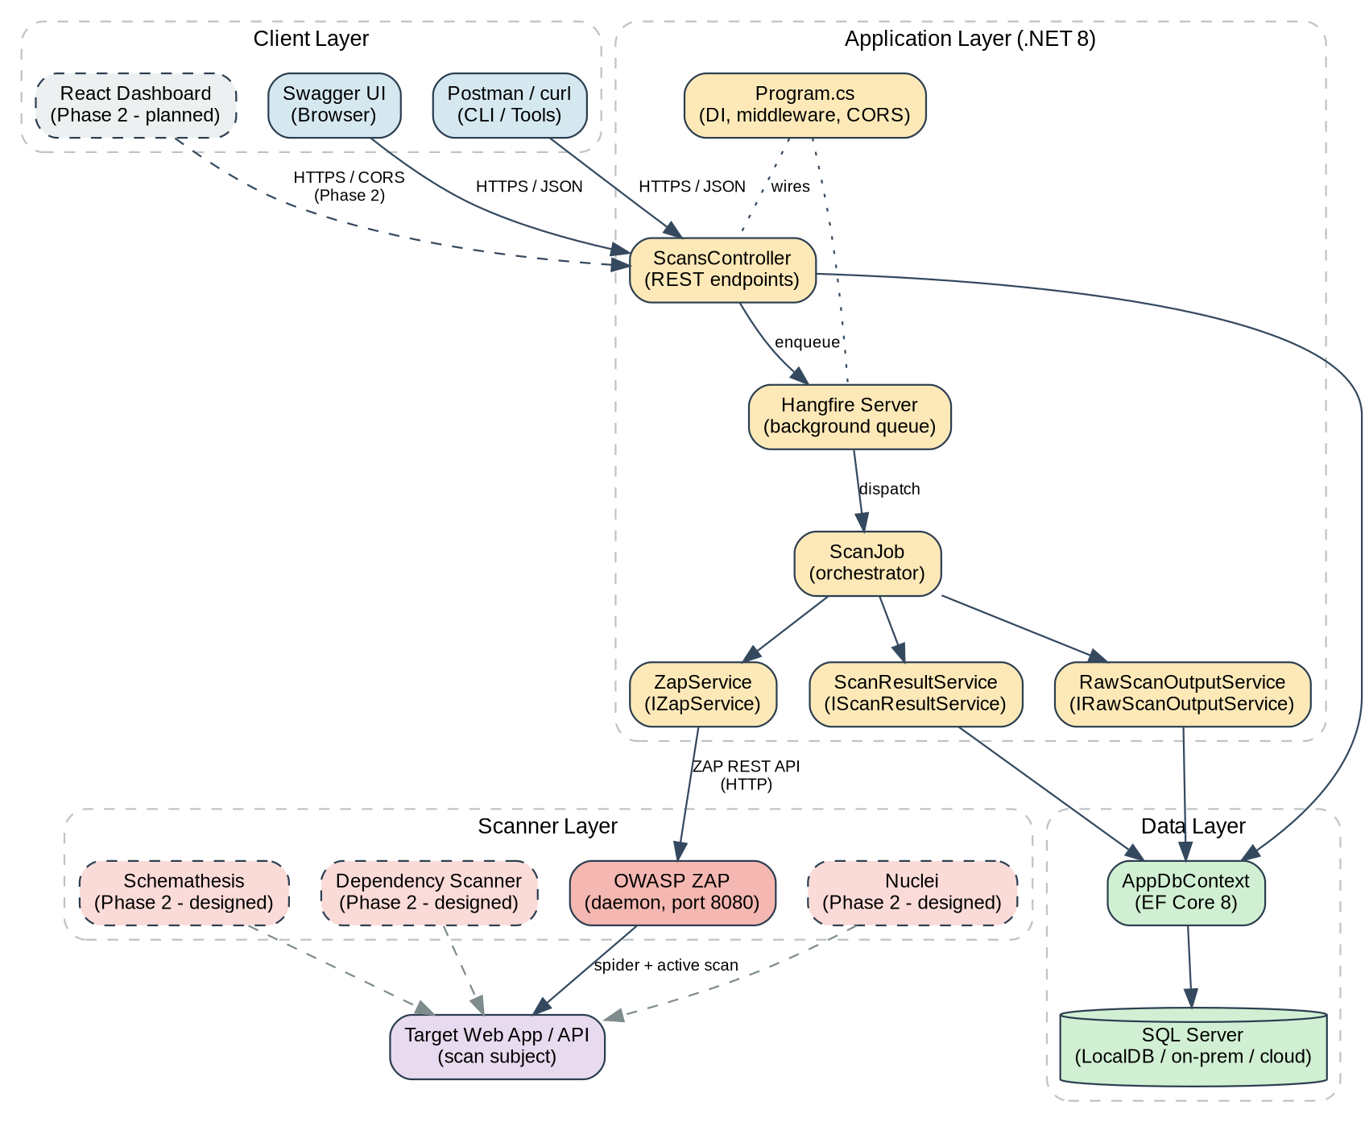
Figure 1: System architecture

The client layer includes Swagger UI, Postman, and curl. A React frontend is planned for Phase 2 but is not part of this deliverable.
The application layer is the .NET 8 Web API. It exposes REST endpoints for scan operations. Hangfire queues long-running scans and runs them in the background. Service classes handle ZAP integration and result parsing.
The scanner layer is OWASP ZAP running as a daemon process. The application calls ZAP via its REST API.
The data layer is SQL Server accessed through Entity Framework Core.

Data Model
The database has three tables: Scan, ScanResult, and RawScanOutput. Figure 2 shows the relationships.
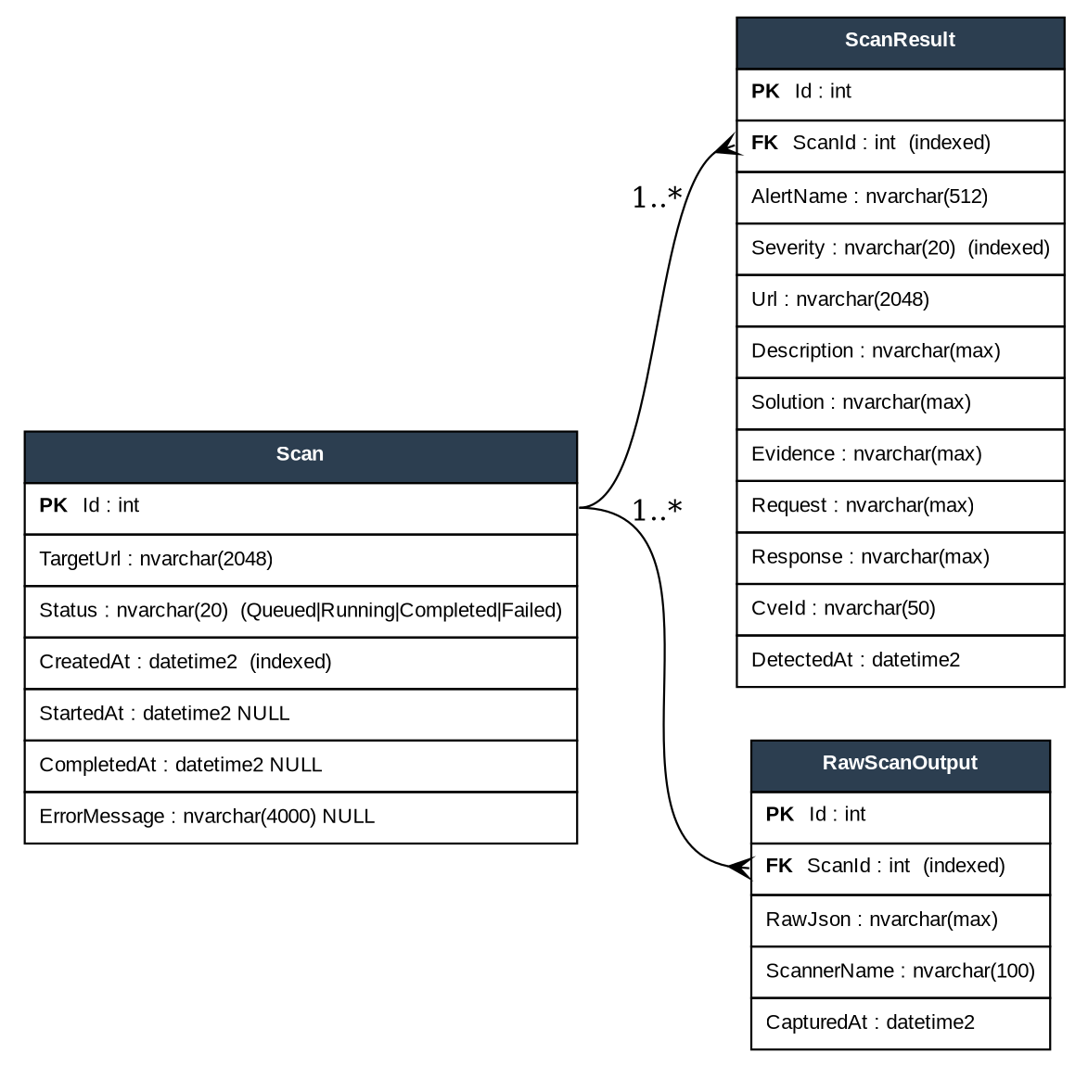
Figure 2: Entity-relationship diagram

The Scan table holds workflow metadata. Each scan has a status (Queued, Running, Completed, or Failed), timestamps, and error message if failed.
The ScanResult table stores one row per ZAP alert. Each row includes the alert name, severity, URL, description, solution, and evidence. Severity is stored as a string for easy querying.
The RawScanOutput table stores the verbatim JSON returned by ZAP. This preserves evidence if the parser changes.

Service Layer
Figure 3 shows the UML class diagram for the service layer.
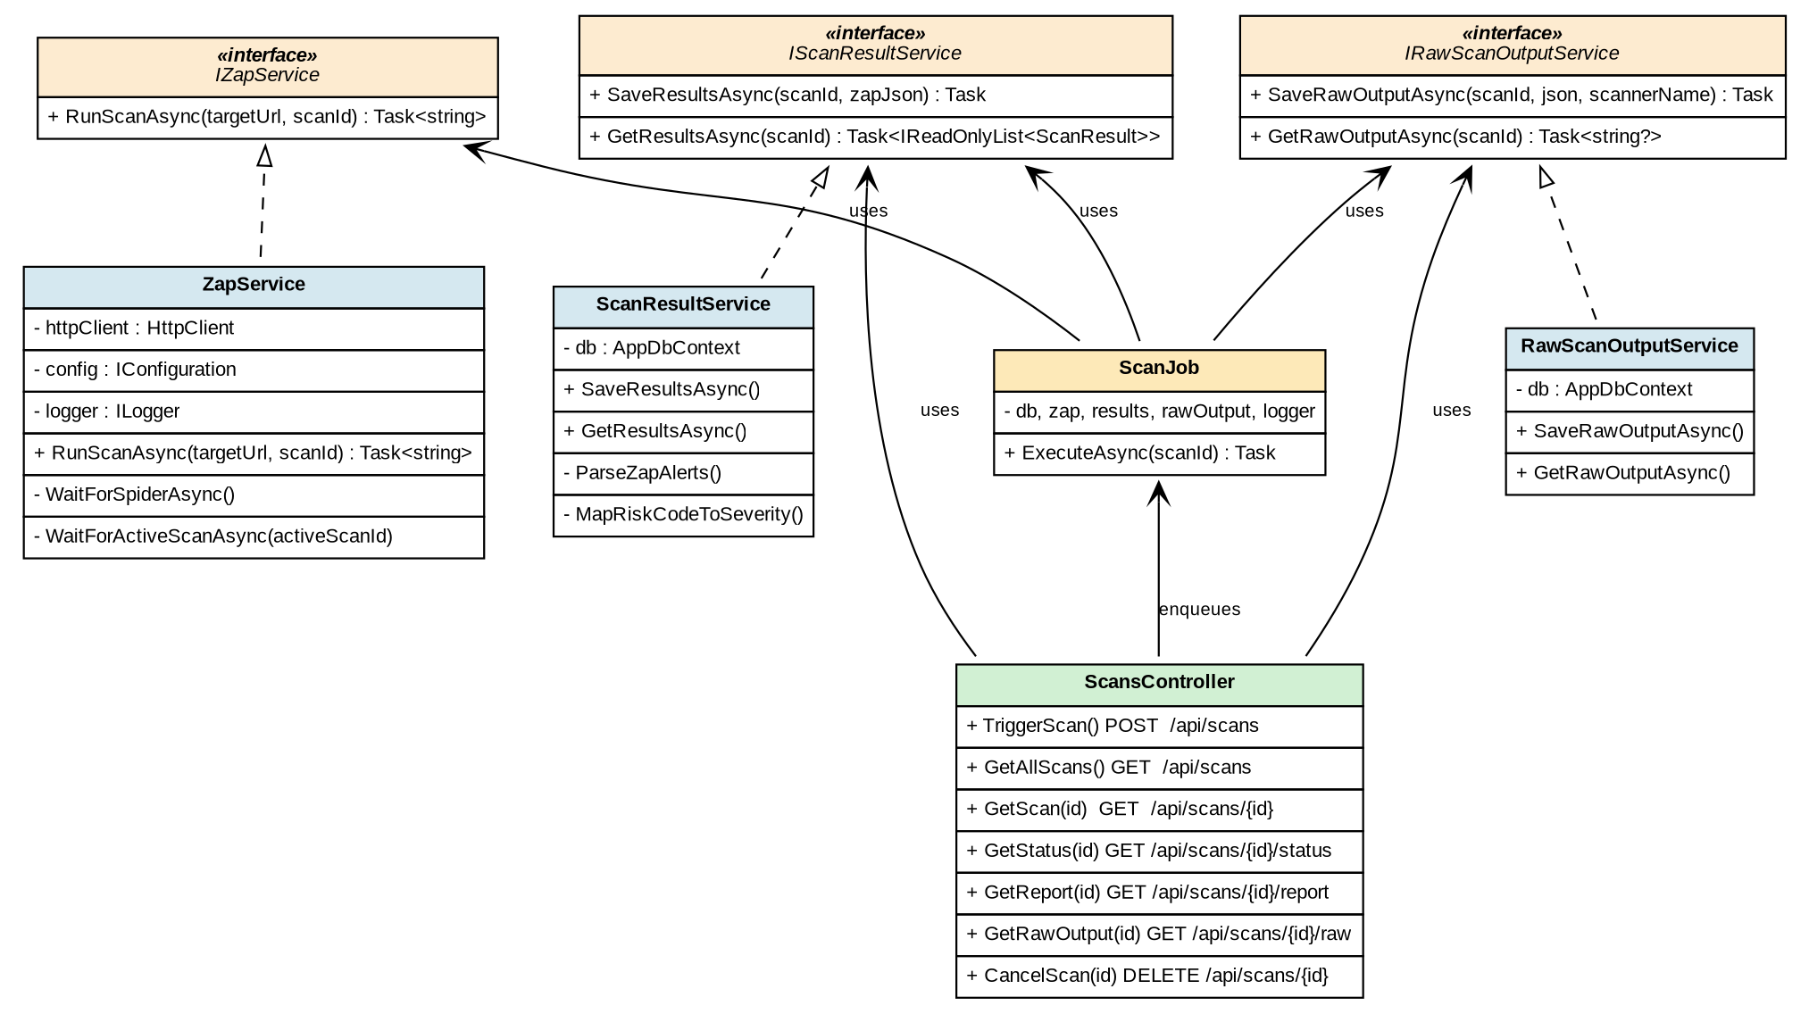
Figure 3: UML class diagram

ZapService handles communication with the ZAP daemon. It sends spider and active scan requests, waits for completion, and retrieves alerts.
ScanResultService parses ZAP JSON and stores findings in the database. It maps ZAP risk codes to severity levels.
RawScanOutputService stores unprocessed scanner output for audit purposes.
ScanJob is the background task that coordinates the other services. Hangfire invokes it when a scan is triggered.

Service Layer
Figure 3 shows the UML class diagram for the service layer.

Figure 3: UML class diagram

ZapService handles communication with the ZAP daemon. It sends spider and active scan requests, waits for completion, and retrieves alerts.
ScanResultService parses ZAP JSON and stores findings in the database. It maps ZAP risk codes to severity levels.
RawScanOutputService stores unprocessed scanner output for audit purposes.
ScanJob is the background task that coordinates the other services. Hangfire invokes it when a scan is triggered.
The user posts a target URL to the API. The API creates a Scan row and enqueues a background job. The job calls ZapService to run the scan. ZAP spiders the target to discover URLs, then runs an active scan against each URL. Results are returned as JSON. The job stores raw output and parsed findings, then marks the scan complete.

Scan Workflow
Figure 4 traces a scan from trigger to completion.

Step | Source | Destination | Action / Description
1 | User (Swagger / Postman) | ScansController | POST /api/scans (Trigger scan)
2 | ScansController | SQL Server | INSERT Scan (Status = Queued)
3 | ScansController | Hangfire | Enqueue<ScanJob>(scan.Id)
4 | User (Swagger / Postman) | ScansController | Returns 202 Accepted (with scan Id)
5 | Hangfire | ScanJob | ExecuteAsync(scanId)
6 | ScanJob | SQL Server | UPDATE Status = Running
7 | ScanJob | OWASP ZAP | RunScanAsync / Launch scan
8 | OWASP ZAP | Target App | spider / active scan
9 | Target App | OWASP ZAP | scan responses
10 | OWASP ZAP | ScanJob | Return scan findings as JSON
11 | ScanJob | SQL Server | INSERT RawScanOutput
12 | ScanJob | SQL Server | UPDATE Status = Completed + ScanResult rows
13 | User (Swagger / Postman) | ScansController | GET /api/scans/{id}/report
14 | ScansController | SQL Server | SELECT Scan (Findings)

Figure 4: Sequence diagram

The user posts a target URL to the API. The API creates a Scan row and enqueues a background job. The job calls ZapService to run the scan. ZAP spiders the target to discover URLs, then runs an active scan against each URL. Results are returned as JSON. The job stores raw output and parsed findings, then marks the scan complete.

Scanner Integration
Phase 1 integrates OWASP ZAP. Three additional scanners are designed but not implemented:
- Nuclei for template-based vulnerability detection
- Schemathesis for API fuzz testing
- Dependency scanning for .NET and React packages
Figure 5 shows OWASP Top 10 coverage by scanner.
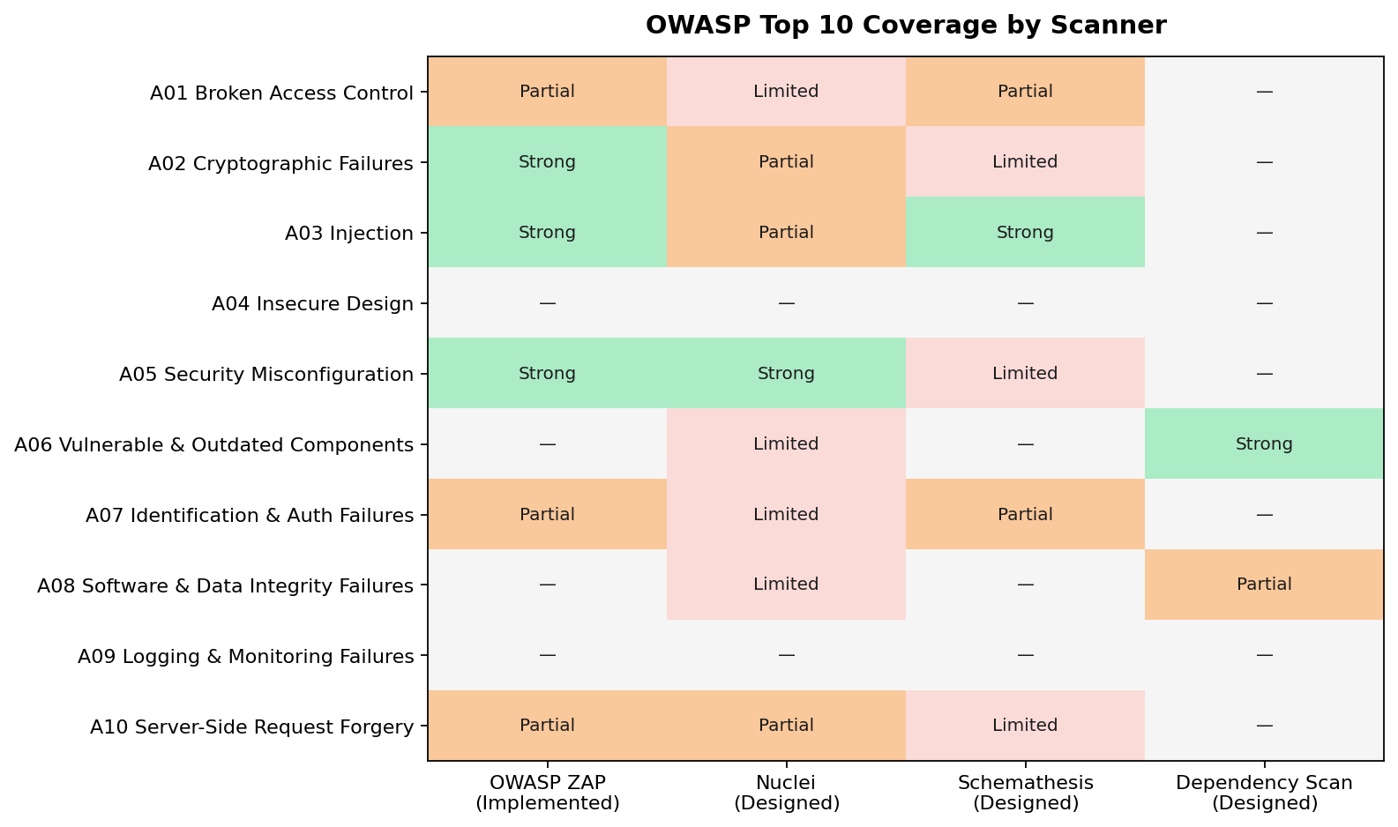
Figure 5: Coverage matrix

ZAP provides strong coverage for injection, security misconfiguration, and cryptographic failures. The other scanners fill gaps in access control, vulnerable components, and API-specific issues.

Data Flow
Figure 6 shows the level-1 data flow diagram.

Process / ID | Source | Destination | Data / Action
1.0 Trigger Scan | Security Engineer | 1.0 Trigger Scan | target URL
 | 1.0 Trigger Scan | 2.0 Queue & Dispatch | scanId
 | 1.0 Trigger Scan | D1: Scans | new Scan row
2.0 Queue & Dispatch | 2.0 Queue & Dispatch | 3.0 Drive ZAP | background dispatch
3.0 Drive ZAP | 3.0 Drive ZAP | D2: RawScanOutput | raw ZAP JSON
 | 3.0 Drive ZAP | Target App (external) | HTTP probes
 | Target App (external) | 3.0 Drive ZAP | responses
 | 3.0 Drive ZAP | 4.0 Parse Alerts | raw JSON
4.0 Parse Alerts | 4.0 Parse Alerts | D3: ScanResult | parsed findings (one row per alert)
 | 4.0 Parse Alerts | D1: Scans | status update
5.0 Serve Reports | Security Engineer | 5.0 Serve Reports | GET /report
 | D1: Scans | 5.0 Serve Reports | Read scan status / data
 | D3: ScanResult | 5.0 Serve Reports | Read parsed findings
 | 5.0 Serve Reports | Security Engineer | ScanReportDto (summary + findings)

Figure 6: Data flow diagram

Security engineers trigger scans, which are queued and dispatched to the ZAP service. ZAP probes the target and returns alerts. The platform parses and stores findings, then serves reports to users.

Threat Model
Figure 7 applies STRIDE threat modeling to the platform.

STRIDE | Category | Example Threat | Impact | Mitigation (Phase 1 baseline)
S | Spoofing | Unauthenticated client triggers scan | Hangfire dashboard or API endpoints abused | API key / OAuth2 / JWT bearer auth (Phase 1.5); Hangfire dashboard protection
T | Tampering | ZAP API key disclosed, scan params altered | Attacker replays scan against arbitrary targets | HTTPS only; ZAP API key in environment variable / Azure Key Vault
R | Repudiation | User denies triggering a scan | No audit trail; cannot prove who scanned | Audit log of every trigger with user id + timestamp; immutable logs
I | Information Disclosure | Scan results contain sensitive endpoints | Leakage of internal URLs, error messages | Role-based access on /report and /raw; row-level filtering for user data
D | Denial of Service | Many scans queued against same target | ZAP daemon overloaded; target rate-limited | Per-user rate limit; concurrent scan cap; queue depth limits
E | Elevation of Privilege | Hangfire dashboard exposed at /hangfire | Unauthenticated user reschedules / cancels | IDashboardAuthorizationFilter in production; reverse proxy restrictions

The main threats are spoofing (unauthenticated access), information disclosure (scan results contain sensitive data), and elevation of privilege (unprotected Hangfire dashboard). Phase 1 mitigates these with HTTPS, environment-variable secrets, and network restrictions. Authentication is planned for Phase 2.

Deployment
Figure 8 shows the deployment topology.

Component Group | Component Name | Details / Specs | Connections (To -> Protocol/Port)
Operator Workstation | Browser | Swagger UI, Hangfire Dashboard | Application Server -> HTTPS
 | curl / Postman | Command line / API client | Application Server -> HTTPS
Application Server | Kestrel + ASP.NET Core 8 | VulnScanner.API (ports 5180 / 7180)  Specs: Linux or Windows, 2 vCPU / 4 GB RAM | Database Server -> TDS 1433
 | Hangfire worker | Same process as API | Database Server -> job state  Scanner Host -> HTTP 8080
Database Server | SQL Server 2019+ | LocalDB for dev (port 1433) | Receives inbound traffic only
Scanner Host | OWASP ZAP | daemon, port 8080  Docker: zaproxy/zap-stable  Specs: Linux, 2 vCPU / 8 GB RAM | Target Web App -> HTTP/HTTPS (scan traffic)
Target Web App | Target Web App | Scan subject | Receives inbound scan traffic only

Figure 8: Deployment diagram

The application server hosts the .NET API and Hangfire worker. The scanner host runs OWASP ZAP in daemon mode. The database server hosts SQL Server. For development, all three roles can run on one machine using LocalDB.

Technology Choices
Component | Selected | Reason
Backend | .NET 8 | Long-term support until November 2026. Strong typing reduces parsing bugs.
Background jobs | Hangfire 1.8 | Persistent jobs survive restarts. Dashboard included.
ORM | EF Core 8 | Code-first migrations. Change tracker simplifies batch inserts.
Database | SQL Server | Required by Hangfire SQL storage provider.
Scanner | OWASP ZAP | Apache 2.0 license. Mature REST API. Maps to OWASP Top 10.

Limitations
Phase 1 has the following limitations:
- No authentication on the API or Hangfire dashboard.
- Only OWASP ZAP is integrated. Other scanners are designed but not implemented.
- No report export to PDF, HTML, or CSV.
- No authenticated scan mode.
- No React frontend. Users interact through Swagger or curl.

Conclusion
The Crennotech Vulnerability Scanner provides a working platform for automated security testing. The backend API integrates OWASP ZAP and stores results in SQL Server. The design supports future scanner additions and a React frontend. Documentation and test coverage meet project requirements.

